

Europass  Curriculum Vitae | 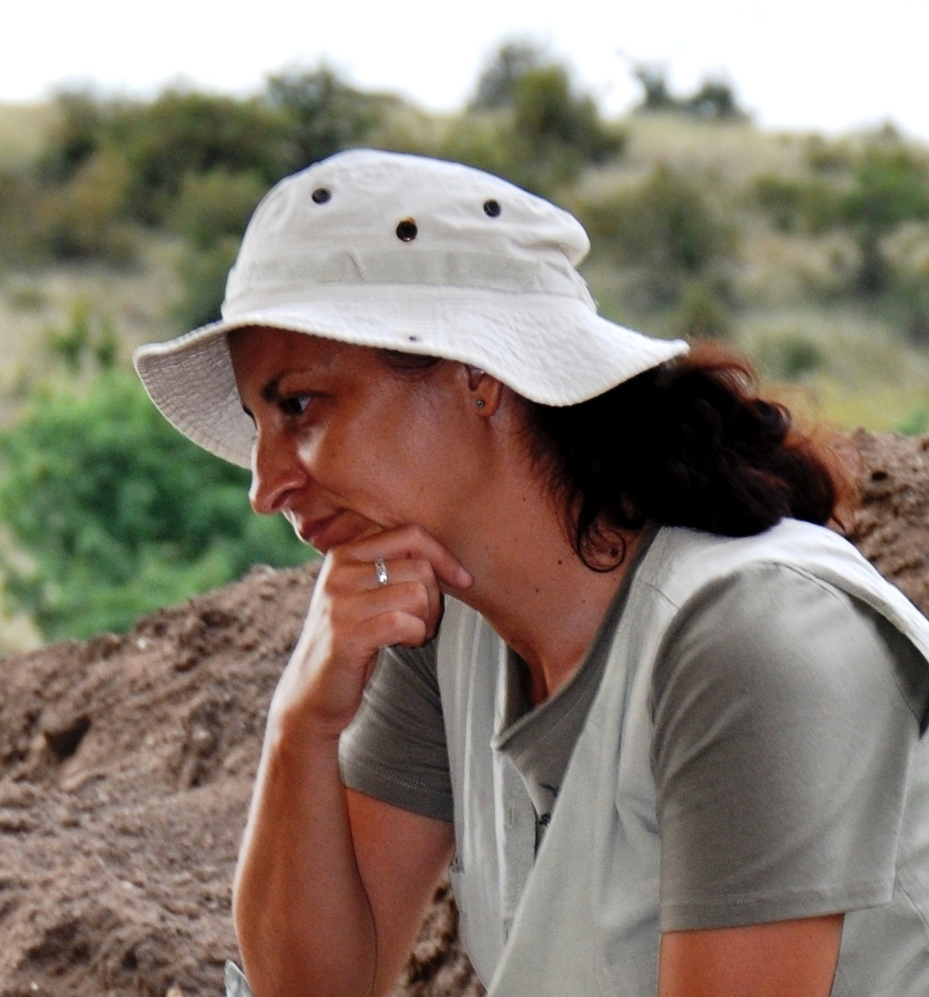
Personal information
First name(s) / Surname(s) | Voinea Valentina
Address(es) | 78, Soveja, Constanta, Romania
Telephone(s) | 0040 241 618 763 |  |  |  |  | Mobile: |  | 0040 722 439 674
Fax(es) | 0040 241 618 763
E-mail | vialia_rahela@yahoo.fr
Nationality | Romanian
Date of birth | 29.03.1969
Gender | female
Work experience
Dates | 2009 Scientific Secretary, Associate lecturer  2006 Scientific Researcher II  1999 Scientific Researcher III  1999 – 2013 Associate lecturer  1996 – 1999 Assistant lecturer
Occupation or position held | Scientific Secretary, Lecturer, Researche
Main activities and responsibilities | Cultural management, archaeological excavations, exhibition activities, editorial activities, teaching activity
Name and address of employer | Museum of National History and Archaeology, Piata Ovidius, 12, 900745, Constanta, Romania  Ovidius University, Bld Mamaia, 1, Constanta, Romania
Type of business or sector | Archaeology / Patrimony, Education
Education and training
Dates | 1997 - 2003
Title of qualification awarded | Ph. D.
Principal subjects/occupational skills covered | History Sciences
Name and type of organisation providing education and training | Institute of Archaeology Vasile Parvan, Romanian Academy – Bucharest, Romania
Level in national or international classification
Dates | 1995 - 1996
Title of qualification awarded | Ma. D.
Principal subjects/occupational skills covered | History Sciences
Name and type of organisation providing education and training | Bucharest University, Faculty of History, Romania
Level in national or international classification
Dates | 1990 - 1995
Title of qualification awarded | Licence D.
Principal subjects/occupational skills covered | History and Archaeology Sciences
Name and type of organisation providing education and training | University Ovidius of Constanta, Romania
Level in national or international classification
Personal skills and competences | art
Mother tongue(s) | Romanian
Other language(s) | French, English
Self-assessment |  |  |  | Understanding |  | Speaking |  |  | Writing
European level (*) |  |  |  | Listening | Reading | Spoken interaction | Spoken production
Language – French |  |  |  | C2 | C2 | C2 | C2 |  | C2
Language - English |  |  |  | C1 | C1 | C1 | C1 |  | C1
 | (*) Common European Framework of Reference for Languages
Social skills and competences  Organizational skills and competences  Computer skills and competences | Ability to interdisciplinary dialogue  Management capacities for cultural activities and archaeological research acquired during projects of the Museum for National History and Archaeology Constanta and University Ovidius of Constanta  Microsoft Office, Corel
Artistic skills and competences | On site archaeological drawing, computer graphics
Other skills and competences | Biodiversity
Annexes | List of published works  Books:  Ceramica complexului cultural Gumelniţa – Karanovo VI. Fazele A1 şi A2, Ed. Ex Ponto, Constanta, 2005.  Studies, articles selective:  - V. Voinea, Artifacts made from hard raw material of animal origin, Cercetări Arheologice, Bucureşti 10, 1997, p. 72 – 84.  - D. Popovici, B. Randoin, Y. Rialland, V. Voinea, Fl. Vlad, C. & C. Bem, G. Haită, .Les recherches archéologiques du tell de Hârşova (dép. De Constantza) 1997 – 1998, Cercetări Arheologice, XI, partea I, 1998 – 2000, p. 13 – 34.  - S. Marinescu-Bîlcu, V. Voinea, St. Dumitrescu, Aşezarea eneolitică de pe Insula „La Ostrov”, Lacul Taşaul, Năvodari. Raport preliminar – campaniile 1999 – 2000, Pontica 33 - 34, 2000 – 2001, p. 123 – 170.  - V. Voinea, Sacralizarea spaţiului locuit. Sacrificiile umane, Cultură şi Civilizaţie la Dunărea de Jos 16 - 17, Călăraşi 2001, p. 35 – 41.  - V. Voinea, Adoratio et invocatio. Gesturi religioase ancestrale reprezentate pe vase de cult gumelniţene, Cultură şi Civilizaţie la Dunărea de Jos 19, 2002, p. 112 – 122.  - V. Voinea, C. Dobrinescu, Aşezarea Hamangia III de la Cheia. Campaniile 2001 – 2002 (Raport preliminar), Pontica 35 - 36, 2002-2003, p. 9 – 23.  - V. Voinea, Cultura Gumelniţa în centrul şi sudul Dobrogei, vol. Studii istorice dobrogene, Ovidius University Press, Constanţa, 2003, p. 13 – 29.  S. Marinescu-Bîlcu, V. Voinea, Ace de păr descoperite în tell-ul de la Atmageaua Tătărască, vol. Prinos lui Petre Diaconu la 80 de ani, Istros, 2004, p. 35 – 40.  – V. Voinea, Cause privind sfârşitul Eneoliticului în zona litoralului Vest-Pontic. Aşezarea de pe Insula La Ostrov, Lacul Taşaul (Năvodari, Constanţa), Pontica 37 – 38, 2004 – 2005, p. 21 – 46.  - V. Voinea, G. Neagu, Începutul eneoliticului în Dobrogea: între prejudecăţi şi certitudini, Studii de Preistorie 3, 2005 – 2006, p. 149 – 131.  - V. Voinea, G. Neagu, Ceramica Hamangia III, Pontica 39, 2006, p. 9 – 34.  V. Voinea, C. Dobrinescu, A. Bălăşescu, V. Radu, The Hamangia settlement at Cheia, Costantza County, Romania, The European Archaeologist, 2006 – 2007, 26: Winter, p. 10-11.  - V. Voinea, About figurines en violon within the civilisation Gumelnita – Karanovo VI, Sprawozdania Archeologiczne 60, 2008, p. 73 – 101.  - Popovici, Dorin Mircea; Bogdan, Crenguta Madalina; Matei, Andreea; Voinea, Valentina; Popovici, Norina, Virtual heritage reconstruction based on an ontological description of the artifacts. International journal of computers communications & control, 3, 2008, p. 460-464
- V. Voinea, Gestures and Meanings in the Art of Gumelnita Culture, vol. Die Archaologie der Prahistorischen Spiritualitat in dem Karpathen-Pontus-Donau-Raum, Constanţa, 2009, p. 103 – 118.
- V. Voinea, G. Neagu, V. Radu, Spondyllus Shell Artefacts in Hamangia Culture, Pontica 42, 2009, p. 9 – 26.
- - V. Voinea, Un nou simbol Hamangia, Studii de Preistorie 7, 2010, p. 45 – 59.
- V. Voinea, B. Szmoniewski, O groapă rituală descoperită în Peştera Craniilor din zona Cheilor Dobrogei (com. Grădina, jud. Constanţa), Pontica 43, 2010, p. 191 - 202.
- D.M. Popovici, V. Voinea, C. Ilie, M. Polceanu, V. Rizea, V. Hramco, Reconstituirea virtuală a Edificiului Roman cu Mozaic, Pontica 43, 2010, p. 555 – 562.
- V. Voinea, Funeral rites in the Hamangia culture: animal sacrifices, Sprawozdania Archeologiczne 62, 2010, p. 65 - 91.
- G. Caraivan, V. Voinea, Potenţialul patrimoniului preistoric submers de pe sectorul sudic al platformei continentale româneşti a Mării Negre, Buletinul Directiei Hidrografice Maritime,nr.IV, Editura Directiei Hidrografice Maritime, Constanta, 2011, p. 33-42.
- V. Voinea, Gl. Caraivan, Human - Environment Coevolution in Western Black Sea Coastal Region (5th MIillennium BC), vol. The Lower Danube in Prehistory: Landscape Changes and Human – Environment Interactions, 2011, p. 49 – 59.
- B. Szmoniewski, V. Voinea, Погребение тюркского кочевника, открытое в пещере Баба в средней Добрудже в Румынии, Stratum Plus, 5, 2011, p. 287 – 296.
- V. Voinea, B. Szmoniewski, Din nou despre Pestera Casian, Pontica 44, 2011, p. 221 – 238.
- V. Voinea, B. Szmoniewski, Coabitări şi simbioze culturale în Eneoliticul din Dobrogea. Studiu de caz: Cheile Dobrogei, Pontica 45, 2012, p. 9 – 25.
- B. Szmoniewski , V. Voinea, Pogrebienie tjurskogo kochevnika v peschere Baba v Severenoj Dobrudzhe : svidetelstvo prisutstvija pechenegov v regionie, [in:] Istrorija I kultura srednovekovych narodov stepnoj Evrazii, A.A. Tyshkin ed., Barnaul, 2012, p. 150-152.
- V. Voinea, B. Szmoniewski, Dynamique de l'habitation Néolithique jusqu’au début de la période Médiévale dans la région Cheile Dobrogei – Vallée Casimcea, vol. Recherches croisées en Dobrogea, Annales. Académie Polonaise de Sciences, Centre Scientiphique à Paris vol 15, 2013, p. 189 – 204.
- C. Tornero, A. Balasescu, J. Ughetto-Monfrin; V. Voinea; M. Balasse, Seasonality and season of birth in Early Eneolithic sheep from Cheia (Romania): methodological advances and implications for animal economy, Journal of Archaeological Science, 13, 118, 2013, pp. 4039 - 4055.
- M. Balasse, C. Tornero, S. Brehard, J. Ughetto-Monfrin, V. Voinea, A. Bălășescu, Cattle and sheep herding at Cheia, Romania, at the turn of the fifth millennium cal BC: a view from stable isotope analysis, vol. Early Farmers. The View from Archaeology and Science, (Alasdair Whittle, Penny Bickle eds.) , British Academy, Proceedings of the British Academy Vol. 198, 2014, p. 115 – 142.
- V. Voinea, Gl. Caraivan, M. Florea, Holocene landscape changes and eneolithic settlements dynamics on the western Black Sea coast, Pontica 48-49, 2015-2016, p. 147 – 176.
- G. Caraivan, Gh. Oaie, A. Seghedi, C. Chera, R. Boşneagu, V. Voinea, HERAS Submarine Archaeological Heritage of the Black Sea Shelf, HERAS BOOK, GeoEcoMar, Constanța – Varna 2015.
- P. Pétrequin, M. Errera, V. Voinea, T. Tsonev, S. Turcanu, D. Şerbănescu, From the Alps to the Balkan (Bulgaria, Greece and Rumania), in: JADE, Social interpretations of object-signs of Alpine jades in Neolithic Europe, Tome 3, Cap 18, 2017, p. 467 – 490; Description typologique des haches en jades alpins de Bulgarie, Roumanie et Ukraine, Tome 4, Annexe 18, 2017, p. 1362 – 1369.
- G. Caraivan, V. Voinea, C. Cerchia, Chapter 18: Submerged Prehistoric Heritage Potential of the Romanian Black Sea Shelf, in N. C. Flemming, J. Harff, D. Moura, A. Burges, G.N. Bailey (eds.), Submerged Landscapes of the European Continental Shelf: Quaternary Paleoenvironments, 2017, p. 497 – 510.
- P. Petrequin, S. Cassen, M. Errera, A. Sheridan, T. Tsonev, S. Turcanu, V. Voinea, The Europe of jade. From the Alps to the Black Sea, in : L. Manolakakis, N. Schlanger et A. Coudard (eds.), European Archaeology. Identities and migrations. Leiden, Sidestone Press, 2017, p. 285-298.
- G. Caraivan, J. Bujini, G. Ion, R. Dimitriu, A. Popa, M. Mureșean, A. Teacă, M. Popa, V. Voinea, C. Dobrinescu, P. Peev, A. Krastev, R. Bekova, M. Panayotova, Western Black Sea Underwater Cultural Touristic Routes, GEOECOMAR, Constanța, 2018.
- M. Mărgarit, V. Voinea - Production of bone rings in the Hamangia settlement of Cheia (Romania), Pontica 53, 2020, p. 91-110.
- B. Szmoniewski, V. Voinea, Ключи Добруджи: что говорят раннесредневековые находки о людях, живших в пещерах / Cheile Dobrogei: what the Early Medieval Items Found at the Caves Tell us about the People who Lived There, Stratum plus 5, 2020, p. 295 – 312.
- C. Haită, V. Voinea, B. Szmoniewski, Analiza micromorfologică a secvenței stratigrafice inferioare din situl Peștera „Craniilor” (sat Cheia, jud. Constanța), Studii de Preistorie 17, 2020, p. 7 – 19.
- M. Mărgărit, V. Radu, V. Voinea, Learning about the past testing the possible functions of the Unio sp. valve in the Hamangia culture (mill V cal BC), European Journal of Archaeology, Volume 24 , Issue 2, May 2021 , pp. 180 – 203.
- B. Szmoniewski, V. Voinea, The sacred and profane destination of Karst Cave Space. Case study: Cheile Dobrogei, in vol. I. Holubeanu (ed.) History and Theology, Ed. Universitară, 2021, p. 89 – 126.
- V. Voinea, C. Băjenaru, M. Lascu, C. Nopcea, A. Irimia, M. Măiță, A. Gheorghe, Complexe Hamangia din situl Techirghiol Dealul Minerva – Paloda. Cercetări arheologice preventive 2020 (Raport preliminar), Pontica 54, 2021, p. 11 – 41.
- I. Dulama, C. Rădulescu, I. Bucurică, S. Teodorescu, R. Ştirbescu, V. Voinea, V. Radu. M. Mărgărit, Non-invasive Analytical Techniques Applied on Pigments Characterization of Ancient Bivalve Shells, Journal of Science and Arts, 2021, 57(4), p. 1121 – 1132.
- V. Radu, M. Mărgărit, V. Voinea, A. Boroneanț, I. D. Dulama. Processing the Testudo carapace in Prehistoric Romania (8th and 5th millennia BC), Archaeological and Anthropological Sciences 14, 60, 2022.
- V. Voinea, B. Szmoniewski, Dinamica locuirilor eneolitice de pe Valea Casimcei, Natur-Culturalia, vol. III, 2022, p. 219 – 230.
- D. Stoicescu, O.G. Duliu, V. Opriş, B. Manea, I. Mariş, V. Voinea, P. Mirea, V. Parnic, M. Dimache, C. Lazăr, Non-Destructive Textural Characterization of Southern Romanian Neolithic and Chalcolithic Pottery Using Digital Image Analysis on Tomographically Reconstructed Sections, Heritage 2023, 6(10), p. 6634-6647.
- V. Voinea, A. Bălășescu, V., M. Mărgărit, C. Băjenaru, A. Irimia, M. MĂIȚĂ, M. Mihon, Al. Petre, C. Mănăilescu, Descoperiri neo-eneolitice în situl Palazu Mare Malul Alb (jud. Constanța). Raport preliminary, Studii de Preistorie, 20, 2023, p. 105 – 180.
- V. Voinea, Limbajul gesturilor în plastica Hamangia, Natur-Culturalia vol V, 2024.
- D.V. Brezoi, A. Iordache, A.I. Gheboianu, V. Voinea, Structural analysis of some pottery fragments belonging to Hamangia (phase III) Culture, The Scientific Bulletin of VALAHIA University MATERIALS and MECHANICS –Vol. 20, No. 22, 2024, p. 25 – 27.

Projects

As archaeologist and archaeological heritage expert:

- Venus at the Lower Danube. Program PHARE CBC (2007-2008).
- Virtual Reality Utilization for Multimodal 3 D Restitution of Historical Sites. Program Proiecte Parteneriate MEC (2007-2010)
- Study of the Prehistoric and Early Mediaeval Settlements in the Casimcea River Valley in Central Dobrudja. Interacademic exchange Polonia-Romania (2010 – 2013).
- Re-constructing the Identities: Facts, Places, Peoples, Animals and objects of the Invisible Past.. PROGRAM Proiecte de Idei MEC (2011 – 2014).
- SPLASHCOS: Submerged Prehistoric Archaeology and Landscapes of the Continental Shelf. PROGRAM EUROPEAN COST(2009 – 2013).
- JADE 2 - Objets-signes et interprétations sociales des jades alpins dans l’Europe Néolithique. PROGRAM CNRS France (2013– 2017).
- HERAS Submarine Archaeological Heritage of the Western Black Sea Shelf. Program PHARE CBC (2013 – 2015).
- Central Dobrudja - Landscape Changes and Human-Environment Interactions from Neolithic to Middle Age. Interacademic exchange Polonia-Romania (2014 – 2016).
- Western Black Sea Underwater Cultural Tourist Routes – programme Thematic Routes on Underwater Cultural Heritage (EASME) (2017 – 2018).
- Dynamic of Biodiversity of the Central Dobrudja from Neolithic to the Ottoman Empire times. Interacademic exchange Polonia-Romania (2019 – 2022).
- Restaurarea moştenirii comune şi promovarea produsului turistic comun, Hamangia – Prima civilizaţie a Vechii Europe, PhareCBC România – Bulgaria (2018 – 2024).
- What do bones tell us? The study of human remains from caves, tumulus and cemetery of Cheile Dobrogei Area, Central Dobrudja, Romania. Interacademic exchange Polonia-Romania (2023-2025).
- Explorarea vieții primilor agricultori din Dobrogea (mileniul al VI–lea BC) PN-IV-P1-PCE-2023-1547 (2025 – 2027).
Grants Abroad:

Grants in France - CNRS, Orleans in 1996, 1997.
Exchange Academic – Cracow – 2010 – 2013; 2014 – 2016;

International Congresses

Athene - Greece 2007, Zadar - Croatia 2007, Rome - Italy, 2008, .Rodos - Greece, 2010, Helsinki - Finland 2012, Rome - Italy 2012, Besançon - France 2013, Paris – France 2013, Szczecin – Poland 2013, Astrakhan – Rusia 2016, Barcelona - Spain 2018, Viena 2021, Kiel 2021, Belfast EAA – 2023, Nitra – 2025.

Archaeological Excavations Abroad

- Orleans – France in 1996, 1997 with Archaeology Museum Orleans.

Specialty Associations Membership

The European Association of Archaeologists

